1. (Working with the balance​ sheet)The Caraway Seed Company grows heirloom tomatoes and sells their seeds. The heirloom tomato plants are preferred by many growers for their superior flavor. At the end of the most recent year the firm had current assets of $ 48,000​, net fixed assets of $ 249, 500​, current liabilities of $ 29 comma 700​, and​ long-term debt of $ 98,700.
a.Calculate​Caraway’s stockholders' equity. Equity is ​$______​(Round to the nearest​ dollar.)
Total assets=297500
=Current assets +Net fixed assets
=48000+249500
Total liabilities
Current liabilities +Long term debt
=29700+98700=128400
Stockholders equity=Total assets –total liabilities
=249500-128400=121100
b. What is the​ firm's net working​ capital?
Current assets –current liabilities
48000-29700=18300
c. If​Caraway’s current liabilities consist of $ 19,300 in accounts payable and $ 10,400 in​ short
Term debt​ (notes payable), what is the​ firm's net working​ capital?
Total current liabilities=29700
Net working capital=48000-29700=18300
2. ​(Capital structure​ analysis)The liabilities and​ owners' equity for Campbell Industries is found​: 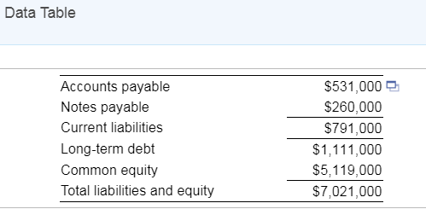
a.What percentage of the​ firm's assets does the firm finance using debt​ (liabilities)? The fraction
of the​ firm's assets that the firm finances using debt is____ ​%. ​(Round to one decimal​ place.)
=7021000-5119000=1902000
1902000/7021000*100=27.1%
b.If Campbell were to purchase a new warehouse for $ 1.2 million and finance it entirely with
long-term debt, what would be the​ firm's new debt​ ratio?
Assets=7021000
Increase=1200000
New structure=7021000+1200000=8221000
Liabilities=1902000+1200000=3102000
Debt ratio=3102000/8221000*100=37.7%
3. (Analyzing Profitability) In​ 2016, the Allen Corporation had sales of $ 64 ​million, total assets of $ 48 ​million, and total liabilities of $ 21 million. The interest rate on the​company’s debt is 5.7 percent, and its tax rate is 35 percent. The operating profit margin is 14 percent.
a. Compute the​firm’s 2016 net operating income and net income.
a. Compute the​ firm's 2016 net operating income and net income. The​ firm's 2016 net operating
income is ​$_____ million. ​ (Round to two decimal​ places.)
Operating margin=operating profit/sale
=14%=x/64000000
=64000000*0.14
Operating income=8960000
Net income computation
Interest expense
0.057*21000000=1197000
8960000-1197000=7763000
Tax=35%
After tax income =1-.35=0.65
Net income=0.65*7763000=2717050
b. Calculate the​firm’s operating return on assets and return on equity.​ (Hint: You can assume
That interest must be paid on all of the​firm’s liabilities.)
Return on assets=operating income/assets
=7763000/48000000=0.16
4. ​(Efficiency analysis)ALei Industries has credit sales of $ 160 million a year. ​ ALei's
Management reviewed its credit policy and decided that it wants to maintain an average
Collection period of 40 days.
a.What is the maximum level of accounts receivable that ALei can carry and have a 40​-day
Average collection​ period?
Accounts receivable =credit*average collection period /365
=160/365*40=17.53
b.If​ ALei's current accounts receivable collection period is 50 ​days, how much would it have to Reduce its level of accounts receivable in order to achieve its goal of 40 ​days?
Accounts receivables for 50 days=160*50/365=21.92
5. ​(DuPont analysis) Dearborn Supplies has total sales of $ 207 ​million, assets of $ 96 ​million, a return on equity of 32 ​percent, and a net profit margin of 7.2 percent. What is the​firm’s debt​ ratio? The​company’s debt ratio is _____ %. ​(Round to one decimal​place.)
Net profit=
Net sales=207000000
Net profit margin=7.2%
Net profit=0.072*207000000=149040
Return on equity=net income /equity=32%=149040/equity
=14904000/0.32=46575000
Debt=total assets-Total equity
Total assets=96000000
Debt=96000000-46575000=49425000
6. ​(Financial statement​ analysis) Carson​ Electronics' management has long viewed BGT Electronics as an industry leader and uses this firm as a model firm for analyzing its own performance. The balance sheets and income statements for the two firms are found​ here:
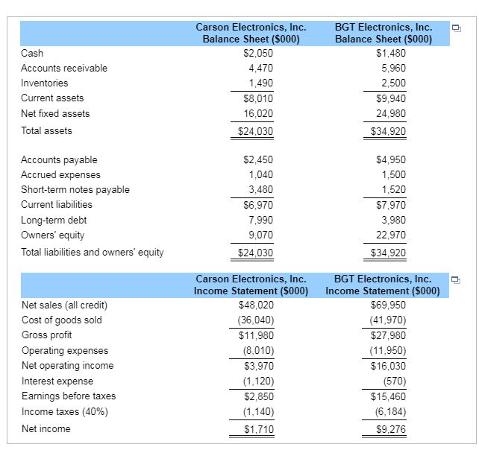
Calculate the following ratios for BGT:

Current ratio=current assets/current liabilities
=9040/7970=1..13
Times interest earned=Earnings before interest and tax/interest expense=16030/570
=28.12
Total asset turnover=net sales /average total assets
=69950/34920=2
Operating profit margin=Operating profit /net sales
=16030/69950=22.92%
Operating return on assets=EBIT/Average Total assets
=16030/34920
=45.9%
Debt Ratio=Total liabilities/total assets
Total liabilities=7970+3980=11950
Total assets=34920
=11950/34920=0.34
Average collection period=Net credit sales/Average accounts receivable
=69950/44950=1.556
365/1.556=235days

Fixed assets turnover
=Net sales /average fixed assets
=69950/24980=24.8

Calculate the following ratios for Carson
Current ratio=Current assets/current liabilities
=8010/6970=1.15
Times interest earned=Earnings before interest and tax/interest expense
=3970/1120=3.5
Operating profit margin=Operating profit /net sales
=3970/48020
=8.27%
Operating return on assets=EBIT/Average Total assets
=39070/24030=1.62
Debt Ratio=Total liabilities/total assets
Total liabilities=14960
Total assets=24030
=14960/24030=62.23%
Average collection period=Net credit sales/Average accounts receivable

=48020/4470=10.74273
365/10.74=33.98
Fixed assets turnover=Net sales /average fixed assets

=48020/16020=2.3

b. Analyze the differences you observe between the two firms. Comment on what you view as weaknesses in the performance of Carson as compared to BGT that​ Carson's management might focus on to improve its operations.

7.(Efficiency analysis)The Brenmar Sales Company had a gross profit margin​ (gross profits divided by ​sales) of 34 percent and sales of $ 8.3 million last year.73 percent of the​ firm's sales are on​ credit, and the remainder are cash sales. ​ Brenmar's current assets equal $ 1.7 ​million, its current liabilities equal $ 298,900​, and it has $ 105,400 in cash plus marketable securities.
a. If​ Brenmar's accounts receivable equal $ 562,100​, what is its average collection​ period? The​ company's average collection period will be ____ days? ​(Round to two decimal​ places.)
Credit sales=0.73*8300000=6059000
Receivables turnover ratio=net credit sales/average receivables =6059000/562100=10.78
Average collection period=365/10.78=33.86
b. If Brenmar reduces its average collection period to 20 ​days, what will be its new level of accounts​ receivable?
New level of accounts receivable=365/20=18.25
Average receivables=6059000/18.25=332000
c. ​Brenmar's inventory turnover ratio is 8.6 times. What is the level of​ Brenmar's inventories?
Inventory turnover period=COGS/Average inventory
Gross profit margin=gross profit/sales
0.34=gross profit/8300000=2822000
COGS=8300000-2822000=5478000
8.6 times=5478000/inventories=636976.74
8) Financial statement​ analysis)The annual sales for​ Salco, Inc. were $ 4.59 million last year. The​ firm's end-of-year balance sheet was as​ follows: 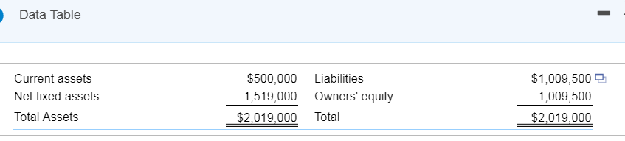 Salco's income statement for the year was as​ follows: 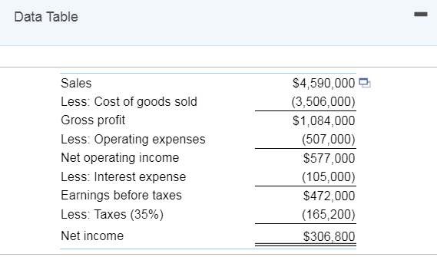
a. Calculate​ Salco's total asset​ turnover, operating profit​ margin, and operating return on assets.
The​ company's total asset turnover is ______ times. ​(Round to two decimal​ places.)
Assets turnover=sales/assets=4590000/2019000=2.27
Operating profit margin=operating income/assets
=577000/2019000=28.58%
b. Salco plans to renovate one of its plants and the renovation will require an added investment in plant and equipment of $ 1.05 million. The firm will maintain its present debt ratio of 50 percent when financing the new investment and expects sales to remain constant. The operating profit margin will rise to 13.6 percent. What will be the new operating return on assets ratio​ (i.e., net operating income divided by total ​assets) for Salco after the​ plant's renovation?
New assets=2019000+1050000=3069000
Sales=4590000 which will remain constant
Operating margin=13.6% pf the sales
=13.6%*4590000=624240
The operating return on assets=New operating income/new assets
=624240/3069000=20.34%
c. Given that the plant renovation in part ​(b​) occurs and​ Salco's interest expense rises by $ 45,000 per​ year, what will be the return earned on the common​ stockholders' investment? Compare this rate of return with that earned before the renovation. Based on this​comparison, did the renovation have a favorable effect on the profitability of the​ firm?
Initial net income=306800
New net income=operating income –interest-tax=
=624240-(45000+105000)*(1-0.35)=308256
9. ​​ (Present value)Ronen Consulting has just realized an accounting error that has resulted in an unfunded liability of ​$380,000 due in 26 years. In other​ words, they will need ​$380,000 in 26 years. Toni​ Flanders, the​ company's CEO, is scrambling to discount the liability to the present to assist in valuing the​ firm's stock. If the appropriate discount rate is 9 ​percent, what is the present value of the​ liability? If the appropriate discount rate is 9 ​percent, the present value of the $380,000 liability due in 26 years is ​$ _____.
Liability 380000
Due time 26 years
Discount rate 9%
=pv= 1/(1+r)^n
1/(1.09)^26=0.10639
380000*0.10639=40429.15
10. ​​(Solving for i​) Lance Murdock purchased a wooden statue of a Conquistador for $ 7,200 to put in his home office 6 years ago. Lance has recently​ married, and his home office is being converted into a sewing room. His new​ wife, who has far better taste than​ Lance, thinks the Conquistador is hideous and must go immediately. Lance decided to sell it on​ e-Bay and only received ​$5,200 for​ it, and so he took a loss on the investment. What was his rate of​ return, that​ is, the value of i​? What was Lance​ Murdock's rate of​ return, that​ is, the value of i​? Enter a negative percentage for a loss. ____​% ​ (Round to two decimal​ places.) present value=Future value/(1+rate)^number of goods
7200=5200/(1+r)^6
5200/7200=0.72222=(1+r)^-8
r=0.72222^(1/8)-1
=-3.99%
11. ​(Future value of an ordinary​ annuity) What is the future value of ​$490 per year for 8 years compounded annually at 9 ​percent? The future value of ​$490 per year for 8 years compounded annually at 9 percent is ​$_____. ​(Round to the nearest​ cent.)
Future value of annuity = P×((1+r)^n-1)/r
R= interest rate
P = payment per period
n = number of payments
= 490×((1+9%)^8-1)/9%
= 5,403.95

12. (Present value of an ordinary​ annuity)What is the present value of ​$2,500 per year for 9 years discounted back to the present at 10 ​percent?The present value of ​$2,500 per year for 9 years discounted back to the present at 10 percent is ​$___.
N = 9
PV = -2500
PMT = 0
= P×[1-(1/(1+r)^n))]/r
FV = 2500*6.398915
=-15997.28
13. ​(Future value of an ordinary​ annuity)You are graduating from college at the end of this semester and after reading the The Business of Life box in this​ chapter, you have decided to invest ​$5,800 at the end of each year into a Roth IRA for the next 44 years. If you earn 8% compounded annually on your​ investment, how much will you have when you retire in 44 ​years? How much will you have if you wait 10 years before beginning to save and only make 34 payments into your retirement​ account? How much will you have when you retire in 44 years?
Value of investment after 44 years =
Value of investment after 34 years
Annual Investment P = 5800
Period of investment n = 44 years
Rate of interest n = 8% or 0.080 (compounded annually)
Future value of annuity can be calculated using the formula
Future value of annuity = Annity amount * [((1+r)^n – 1)/r]
Value of the investment after 44 years = 5800 * [((1+0.08) ^44– 1) / 0.08] =
Value of investment after 44 years = 1984081.14
In case I wait for 10 years
Value of investment after 34 years = 5800 * [((1+0.08)^35 – 1) / 0.08]
Value of investment after 34 years =992534.69
14. (Annuity payments) Mr. Bill S.​ Preston, Esq., purchased a new house for ​$120,000. He paid ​$30,000 upfront and agreed to pay the rest over the next 15 years in 15 equal annual payments that include principal payments plus 8 percent compound interest on the unpaid balance. What will these equal payments​ be?

- Mr. Bill S.​ Preston, Esq., purchased a new house for ​$120,000 and paid ​$30,000 upfront. How much does he need to borrow to purchase the​ house
House cost=120000
N=15
R=8%
Down payment=30000
=120000-30000=90000
15. ​(Annuity payments)To pay for your​ child's education, you wish to have accumulated ​$20,000 at the end of 11 years. To do​ this, you plan to deposit an equal amount into the bank at the end of each year. If the bank is willing to pay 9 percent compounded​ annually, how much must you deposit each year to obtain your​ goal? The amount of money you must deposit each year in order to obtain your goal is?$__232___
PMT=232
16. ​(Annuity number of​ periods)How long will it take to pay off a loan of ​$48,000 at an annual rate of 11 percent compounded monthly if you make monthly payments of ​$550​? Use five decimal places for the monthly percentage rate in your calculations.
The number of years it takes to pay off the loan is___12_ years.
17. Your folks just called and would like some advice from you. An insurance agent just calledthem and offered them the opportunity to purchase an annuity for ​$21,880.33 that will pay them $2,500 per year for 25 years. They​ don't have the slightest idea what return they would bemaking on their investment of ​$21,880.33. What rate of return would they be​ earning? The annual rate of return your folks would be earning on their investment is ___​%.
PV = present value or price = 21083.33
PMT = periodic payment = 2500
n = number of years = 25
r = interest rate
PV=PMT∗(1−(1+r)−nr/r=
25th root of 21083.33=1.48921
1.48921=1.3182567*1-(1+r)/r
=1.48921r=1.3182567(1+r)
1.48921r=1.3182567+1.3182567r
0.1709r=1.318256
=r=7.71%
18. ​(Loan amortization)On December​ 31, Beth Klemkosky bought a yacht for ​$80,000. She paid ​$16,000 down and agreed to pay the balance in 5 equal annual installments that include both the principal and 14 percent interest on the declining balance. How big will the annual payments​ be?
(1+14%)^5=1.9254
1.14^4=1.688896
0.14/1.1688896=0.11978
1.19254*0.11978=0.202282
=80000*0.202282=16182.61
a.On December​ 31, Beth Klemkosky bought a yacht for ​$80,000 and paid ​$16,000 ​down, how much does she need to borrow to purchase the​ yacht?
She needs to borrow $64000
19. ​(Present value of annuity​ payments) The state​ lottery's million-dollar payout provides for ​$1.3 million to be paid in 20 installments of ​$65,000 per payment. The first ​$65,000 payment is made​ immediately, and the 19 remaining ​$65,000 payments occur at the end of each of the next 19 years. If 8 percent is the discount​ rate, what is the present value of this stream of cash​ flows? If 16 percent is the discount​ rate, what is the present value of the cash​ flows?
a.If 8 percent is the discount​ rate, the present value of the annuity due is ​$___
cash flow/(a+r)^n
=65000*(1/(1.08^19)=15061.28
20. ​(Present value of an uneven stream of payments​) You are given three investment alternatives to analyze. The cash flows from these three investments are as​ follows:
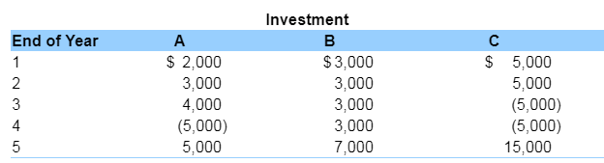
What is the present value of each of these three investments if the appropriate discount rate is 11%
a.What is the present value of investment A at an annual discount rate of 11 ​percent?
A
Years1 2000 *0.9009=1801.8
2 3000*0.8116=2434.86
3 4000*0.73119=2924.77
4-5000*0.6587=-3293.65
5 5000*0.5934=2967.26
PV=2967.26+3293.65+2924.77+2434.86+1801.8=13422.34
21. (Bond valuation)Calculate the value of a bond that matures in 17 years and has a $ 1,000 par value. The annual coupon interest rate is 8 percent and the​ market's required yield to maturity on a​ comparable-risk bond is 13 percent. The value of the bond is ​$___815.19__.

22. ​(Bond valuation) A bond that matures in 20 years has a ​$1,000 par value. The annual coupon interest rate is 12 percent and the​ market's required yield to maturity on a​ comparable-risk bond is 15 percent. What would be the value of this bond if it paid interest​ annually? What would be the value of this bond if it paid interest​ semiannually?
a.The value of this bond if it paid interest annually would be ​$_____.
YTM=12%
(15/1.12)^20+(1000/1.12)^20=2073
23. (Bond valuation)​Pybus, Inc. is considering issuing bonds that will mature in 18 years with an annual coupon rate of 7 percent. Their par value will be ​$1,000​, and the interest will be paid semiannually. Pybus is hoping to get a AA rating on its bonds​ and, if it​ does, the yield to maturity on similar AA bonds is 8.5 percent. ​ However, Pybus is not sure whether the new bonds will receive a AA rating. If they receive an A​ rating, the yield to maturity on similar A bonds is 9.5 percent. What will be the price of these bonds if they receive either an A or a AA​ rating?
- The price of the Pybus bonds if they receive a AA rating will be ​$___.
Price of bond = Interest PV + PV OF Redemption value
PV OF INTEREST = C *F * [ 1-(1+r)^-t / r ]
PV OF REDEMPTION = FACE VALUE /(1+r)^t
Calculation of Pricing under AA Rating :
C= COUPON RATE =.007/2 = 0.035 ,
F = face value = 1000,
T= Period of occurring bond = 18*2 = 36 ,
r = interest rate prevailing in market = .085/2 = 0.0425,
0.035*1000*(1-(1+0.0425)^36/0.0425)=639.477
24. ​(Bond valuation) ​Fingen's 18​-year, ​$1,000 par value bonds pay 13 percent interest
annually. The market price of the bonds is ​$1,060 and the​ market's required yield to
maturity on a​ comparable-risk bond is 11 percent.
a.Compute the​ bond's yield to maturity. What is your yield to maturity on the Fingen bonds given the market price of the bonds?
9%
b.Determine the value of the bond to​ you, given your required rate of return.
946.65
c.Should you purchase the​ bond?
No. The value of the bond is higher than the book value
25. ​(Yield to​ maturity)Abner​ Corporation's bonds mature in 15 years and pay 15 percent
interest annually. If you purchase the bonds for ​$1,175​, what is your yield to​ maturity?
Your yield to maturity on the Abner bonds is ______​%
Yield to maturity =Interest + Face Value - Price / N / Face Value + Price /2
= 0.15+(1000-1175)/15/1000+1175/2=7.25%
=
= 80+(-200)/17/1100
= 80-11.76/1100
= 68.235/1100 i.e 0.062 or 6.20%

26. ​(Bond valuation)The 13​-year ​$1,000 par bonds of Vail Inc. pay 12 percent interest. The​
market's required yield to maturity on a​ comparable-risk bond is 9 percent. The current market price for the bond is $ 1 comma 070.
a.Determine the yield to maturity. What is your yield to maturity on the Vail bonds given the current market price of the​ bonds?
8.14%
b. What is the value of the bonds to you given the yield to maturity on a​ comparable-risk bond?
917.99
c. Should you purchase the bond at the current market​ price?
Investor needs not to purchase the bond since the market value of the bond is higher than the book value.
27. ​(Yield to​ maturity)The Saleemi​ Corporation's ​$1, 000 bonds pay 9 percent interest annually and have 8 years until maturity. You can purchase the bond for ​$895.
a.What is the yield to maturity on this​ bond?
3%
b.Should you purchase the bond if the yield to maturity on a​ comparable-risk bond is 13 ​percent?
Yes since the bond prce is lower than the book value
28. (Bond valuation​ relationships) The 13​-year, ​$1,000 par value bonds of Waco Industries pay 7 percent interest annually. The market price of the bond is ​$945​, and the​ market's required yield to maturity on a​ comparable-risk bond is 6 percent.
a.Compute the​ bond's yield to maturity. What is your yield to maturity on the Waco bonds given the current market price of the​ bonds?
b.Determine the value of the bond to you given the​ market's required yield to maturity on a​ comparable-risk bond.
c.Should you purchase the​ bond?
29. ​(Inflation and interest rates) What would you expect the nominal rate of interest to be if the
real rate is 3.6 percent and the expected inflation rate is 6.6 ​percent? The nominal rate of interest would be _____​%
=1+0.036=1.042=(1+Norminal rate)/1.066
=1.036. *1.066=1.104376=1+n.R
Nominal rate=1.104376-1
=0.104376=10.44%

